HVAC system setup  
Doug Leppard

## Location of files

Sketch files

C:\Users\Doug\My Documents\Arduino

## V 1.08+ and 1.04+

Central Unit

* record temps
* log data to SD
* normalize temps
* time stamps logging
* allow to change the 8 char serial to a human name IE Master
* allow to use any port
* allow to identify special sensor and port

Display

* show temps, only final temp
* give menu input
* send menu commands to central

Central Display

SD card

LCD menu

Xbee sensors

## EEPROM storage

Thee eeprom on the central stores info to be loaded every time program boots

HVAC central eeprom

Has data hard coded in the program and sets the eeprom.

First two bytes

99 = number of sensors to be loaded DEC

For each sensor, one is loaded right after other

SSSSSSSSPTNNNNNNNNNN-9.99F

26 characters

S = sensor low serial, 8 char

P = port number of xbee

T = type sensor what used for

1. normal zone sensor
2. AC in temp
3. AC out temp
4. Register temp (not used yet)

N = name of zone IE Master, 10 char padded with spaces

-9.99 = adjustment to normalize temperature

F = tell if Fahrenheit or Celsius (**not used**)

## HVAC Display

This collects, saves and displays data from the central unit.

Arduino UNO

Xbee Router (2013) to receive and send commands from central unit.

Code: HVAC_Display

To program must change to this board and connect the green USB cable. Can use cable to get print data.

## HVAC Central unit

This unit collects data from the remote endpoint xbee units and passes on the data to the HVAC Display unit. Eventually it will control and the vents and AC unit.

Arduino UNO

Code: HVAC_central_unit

To program disconnect the xbee hooked to board and plug in the programmer

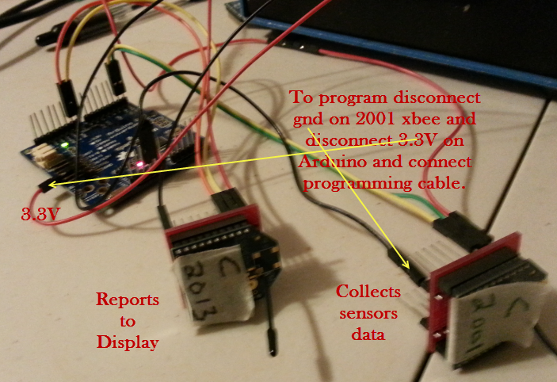

## Proto call

S 99999999 0 77.77 F

99999999 = low serial ID of sensor (8 numbers)

0 = port number, 0-3

77.77 temperature

F

End of line

## Data in eeprom

1099999999 -1.23 one after the other

If 1st digit is 1 it is good data else not good data

2nd digit tells what sensor port 0-3

If not minus

1099999999 1.23

If normalized is 2 digit

10999999999 99.99

If 2 digit minus

10999999999-99.99

16 digits

## Setup endpoint

Note make sure coordinator has same or higher SP setting.

Do the following:

Set XBee as “end device AT”

Using +++ or direct input do following

ATID2001

ATDH0

ATDL0

ATD02

ATIR3E8

ATSM4

ATSP5DC

ATST14

ATWR

## Coordinator of Xbee sensors

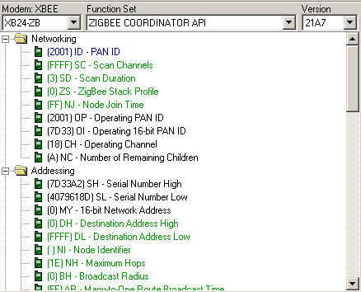

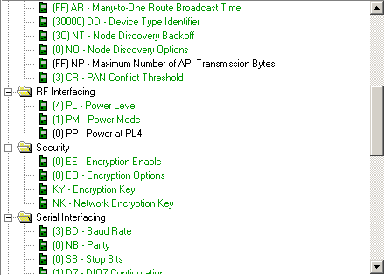

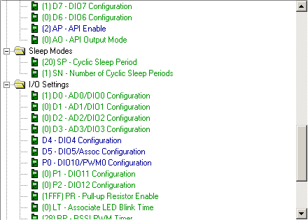

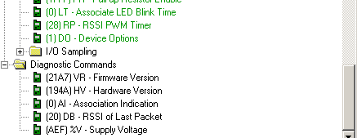

## End point sensor for temperature

This setup was for 1 second need to do 15 seconds

